Early English Books on Microfilm

There are many different descriptions of the Early English Books collection on microfilm, and the associated indexes. The following description was taken from the Library of Congress website. It has been edited to reflect the scope of the collection at the Harris Learning Library.

Early English books, 1475-1640. -- Ann Arbor, Mich. : University Microfilms International, [1938]- . -- [1782]microfilm reels ; 35 mm.
Based primarily on A. W. Pollard's and G. R. Redgrave's Short Title Catalogue (STC) of books printed in England and English books printed elsewhere from the advent of printing in England in 1475 through 1640. Almost all the titles in the STC and many more not listed there will eventually be included in the completed collection. Because of the intended scope of this collection, most books are in English, but there are a number in other languages. The books cover a very wide range of subjects and include numerous ancient and medieval authors. Each reel contains several titles arranged in STC number order, but the filming has not been systematic from beginning to end. Instead, books have been filmed as they have been located in various libraries. Published guides for each unit filmed are periodically cumulated as well as the Cross-lndex from STC number to reel number. This collection is continued by Early English Books, 1641-1700.
LCCN: 84-127515
ELECTRONIC RESOURCES: The English Short Title Catalogue (ESTC) database is freely available through the British Library. It is the most comprehensive index to this collection and includes the microfilm reel numbers for those works that have been filmed as part of the microfilm collection.

Early English books, 1641-1700. -- Ann Arbor, Mich. : University Microfilms International, [1961]- . -- [ ] microfilm reels ; 35 mm.
Based on Donald G. Wing's A Short Title Catalogue from which selected titles are filmed. A number of new titles reported since the bibliography was published are also to be included. Titles are not filmed in Wing number order, but are filmed as they are located in various libraries. This collection covers a wide range of subjects, primarily in English, but also includes some books in other languages. Published guides and cross-indexes from Wing number to reel number for each unit filmed are periodically cumulated. The collection is a continuation of Early English Books, 1475-1640.
LCCN: 89-894010

ELECTRONIC RESOURCES: The English Short Title Catalogue (ESTC) database is freely available through the British Library. It is the most comprehensive index to this collection and includes the microfilm reel numbers for those works that have been filmed as part of the microfilm collection.

The Harris Learning Library holds some of the print indexes that have been published to support this collection. These include a title index covering the period from 1475 – 1640, and the three volume short title catalogue by Donald Wing for 1641-1700. We do not hold the original short title catalogue by Pollard and Redgrave for 1475-1640, and we do not hold the cross-indexes used for locating the microfilm reel numbers.

An alternate method of locating these publications on the microfilm is available from the British Library’s “English Short Title Catalogue (ESTC)” Although this online catalogue contains citations for many early publications from various sources, the following procedure should limit the search to our collection of Early English Books on microfilm.

1. English Short Title Catalogue

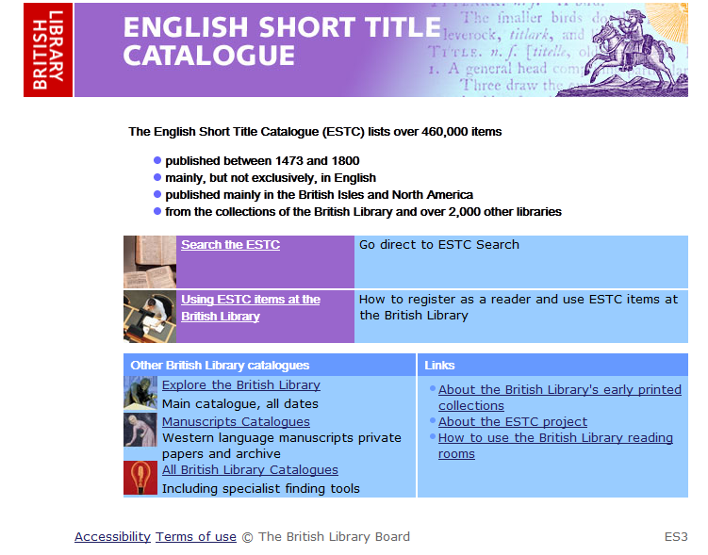

2. Search the ESTC – Advanced Search

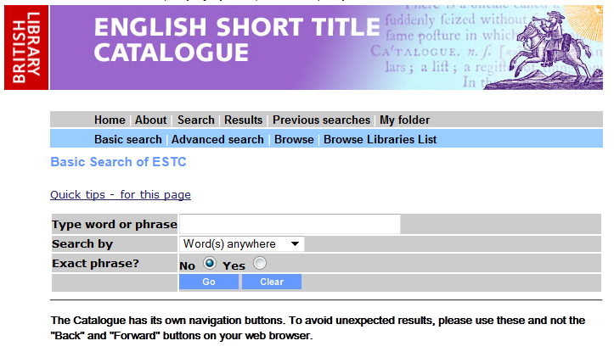

3.

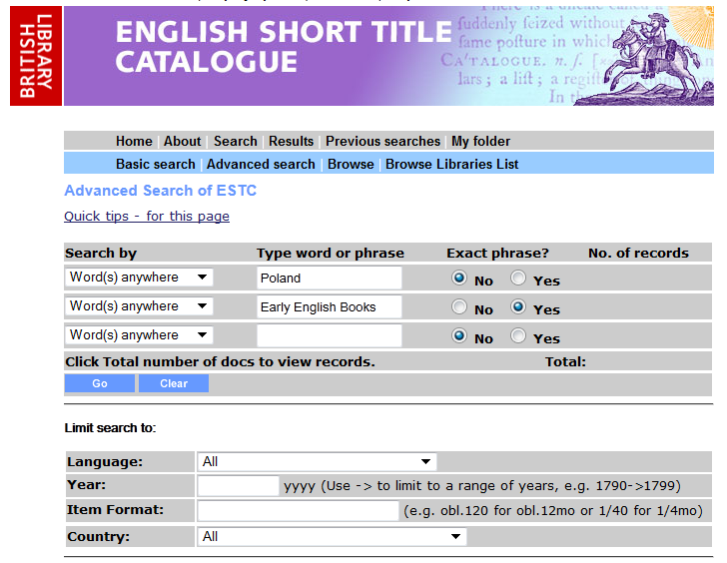

4.

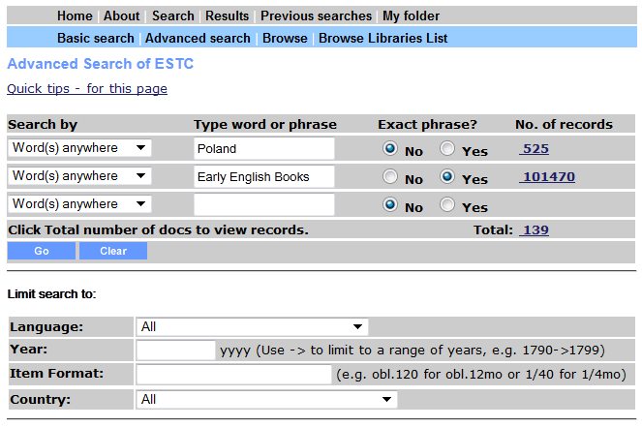

5.

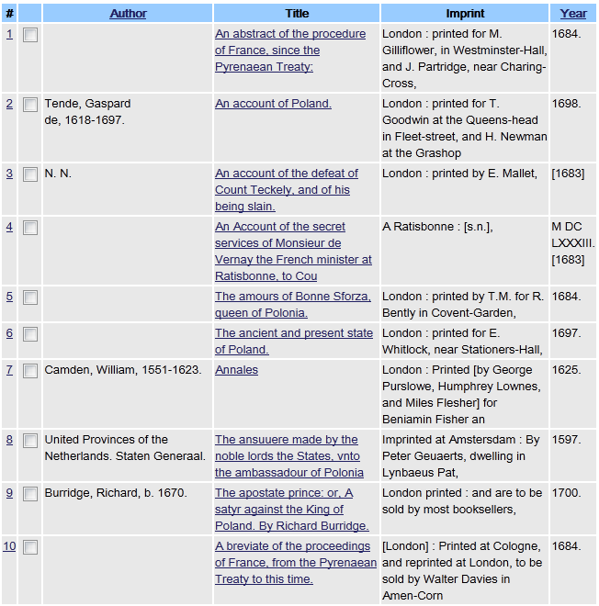

6.

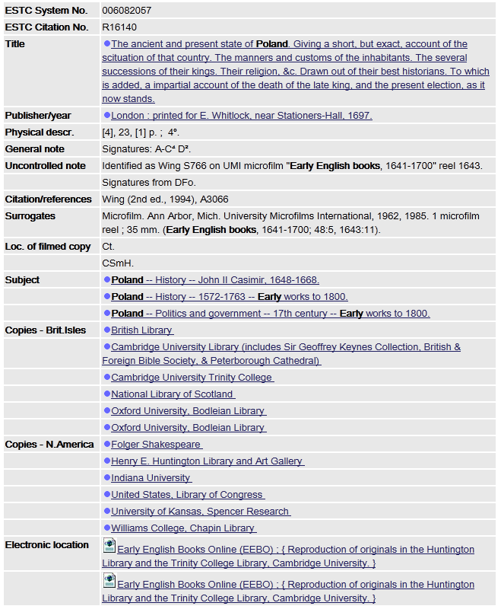

This is available on reel 1643 – the eleventh publication on the reel.

