How to use the Minolta MS6000 Microfilm Reader/Scanner

Updated August, 2015

The MS6000 Microfilm Reader/Scanner is designed to allow the capture of microfilm images as well as printing. Whether you’re printing or just scanning, you’ll need to use the computer together with the MS6000 Microfilm Reader/Scanner.

IF YOU’RE PLANNING TO SAVE IMAGES, you can use a USB drive or a recordable data disc (CD-R or CD-RW). You can also email images to yourself as attachments. Please note that files saved to the computer’s hard drive will be erased when the computer is rebooted.

Step 1) Turn on the Microfilm Reader/Scanner.
The power switch is on the right of the MS6000 Microfilm Reader/Scanner. If the computer is off, please seek staff assistance.

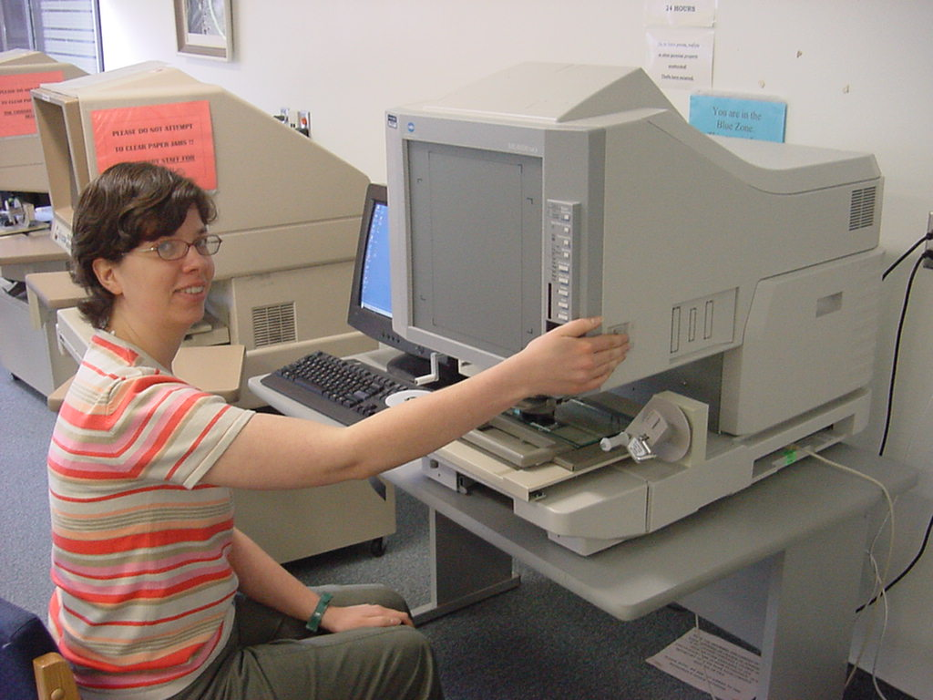
Step 2) Place the microfilm reel on the left spindle. Pull the tray towards you until the glass plate pops up. Feed the microfilm under the rollers and glass as shown.

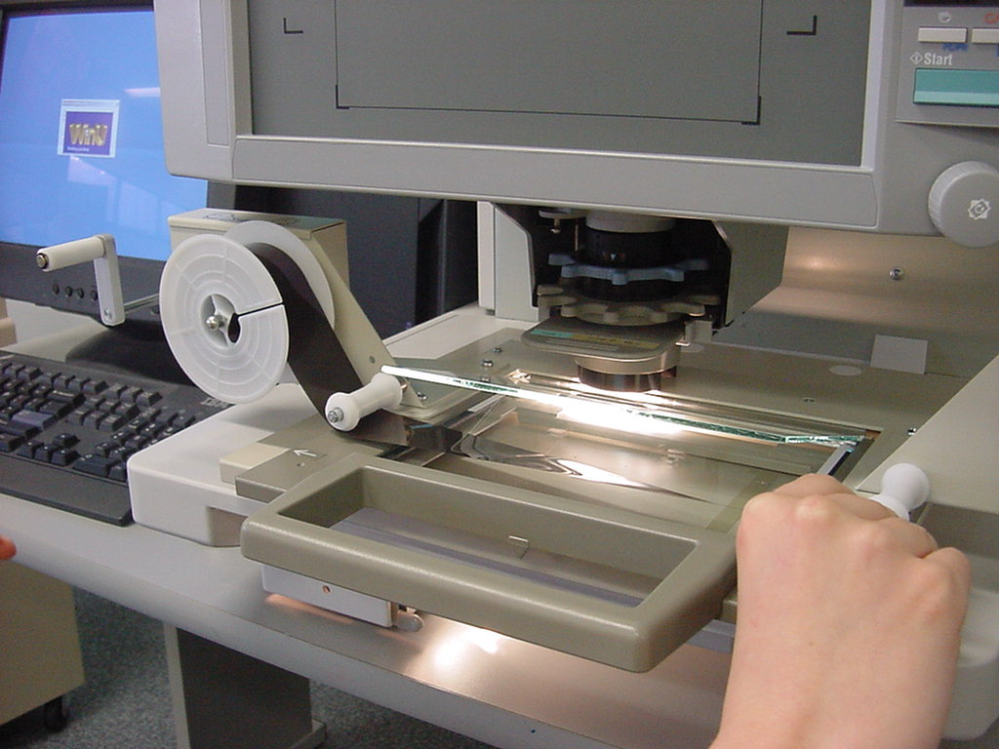
Film goes over top
Pull tray forward all the way
Film goes under the rollers and glass
Push the reel all the way on

Step 3) Feed the microfilm into the take-up reel on the right and wind the microfilm by turning the handle clockwise.

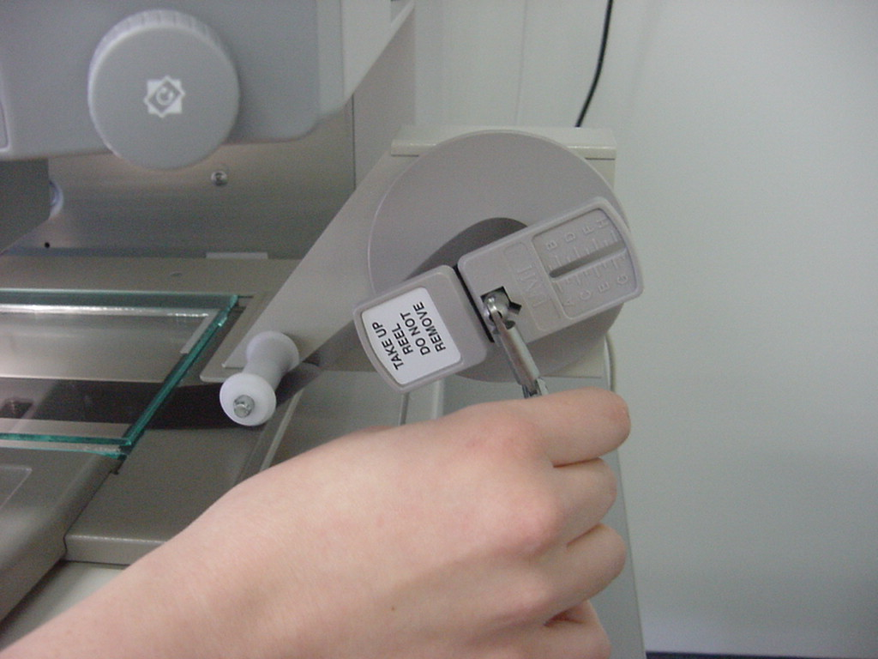
Push the end of the film in this slot before winding
Step 4) Advance to the first page of the document by turning the handle on the take-up reel. If the image is reversed, you’ve put the reel on upside down, and you’ll have to go back to Step 2).

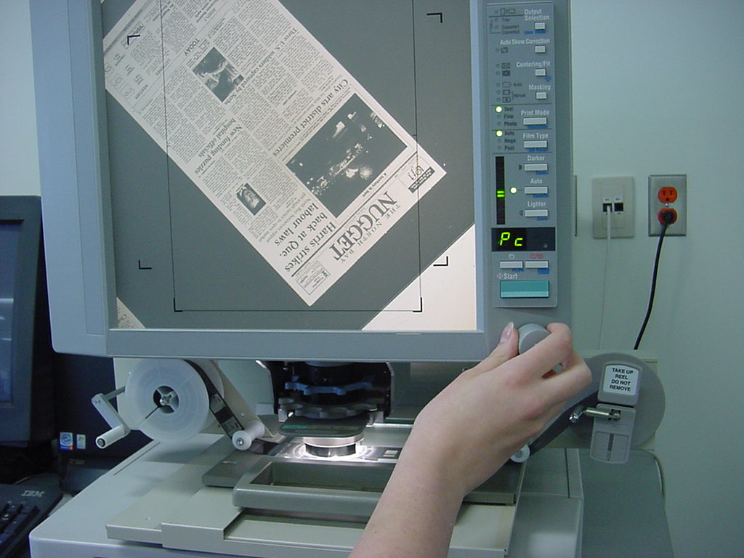
Adjust the orientation of the image by turning this knob to the right or left.

Step 5) Adjust the magnification and zoom, using the grey and blue wheels.

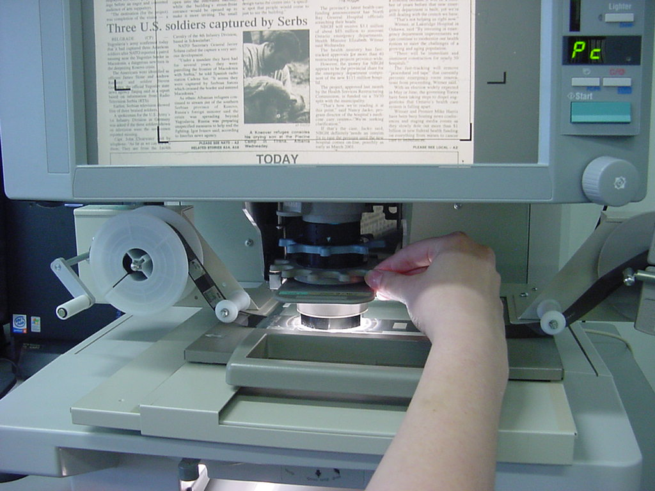
You should see part of the image you want within the black framing guidelines. In the picture below, the article “NATO pounds Belgrade” is centred.

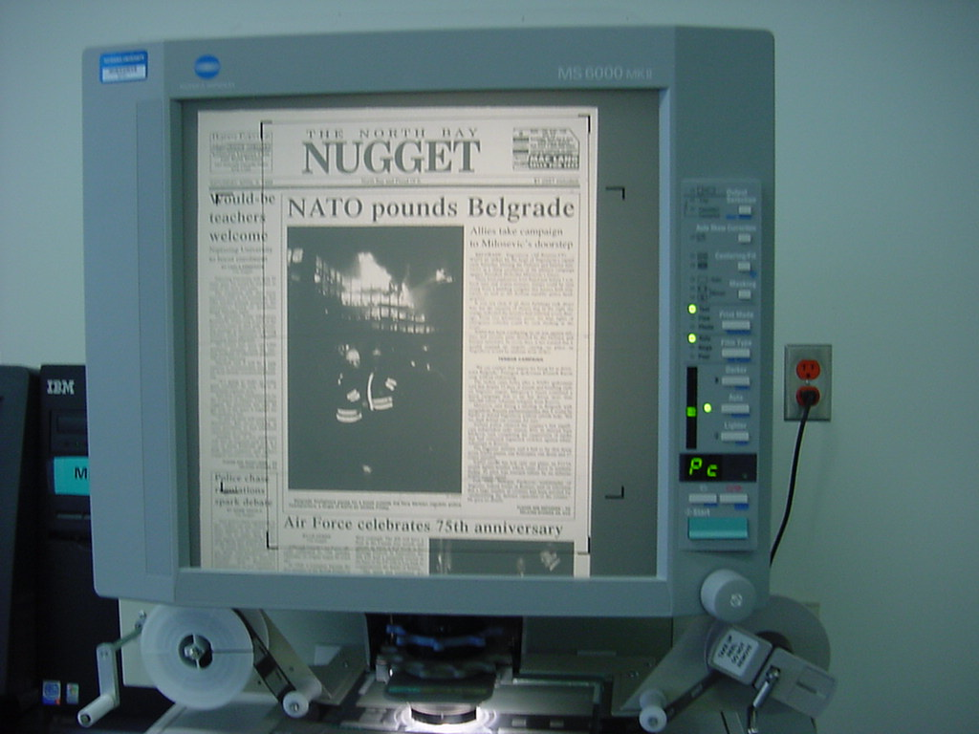

Step 6) Using the computer next to the Microfilm Reader/Scanner, open Adobe Acrobat.

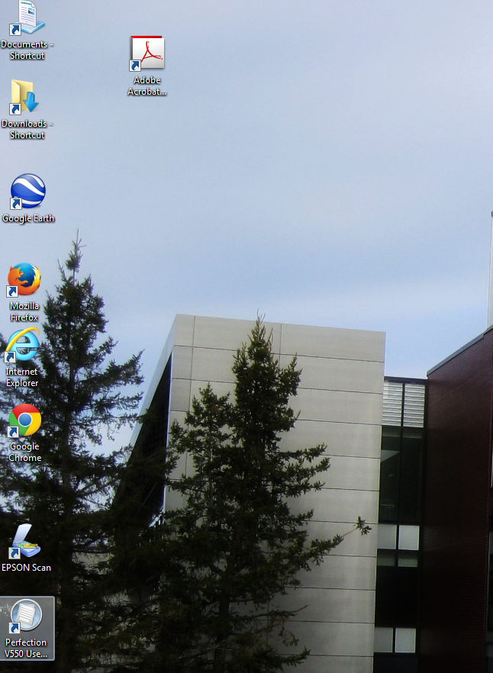

Step 7) Within Acrobat, select Create -> PDF from Scanner -> Custom Scan...

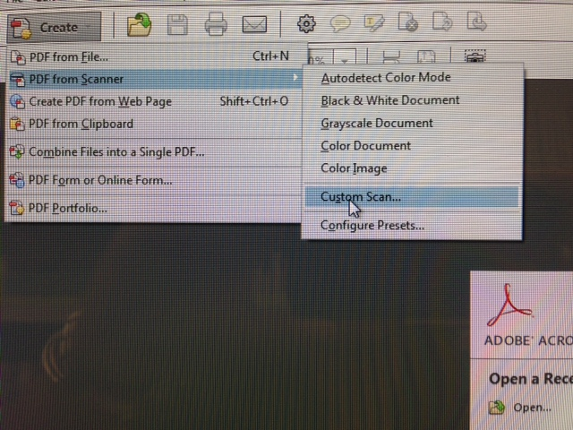

Step 8) On the next screen, click on the Scan button.

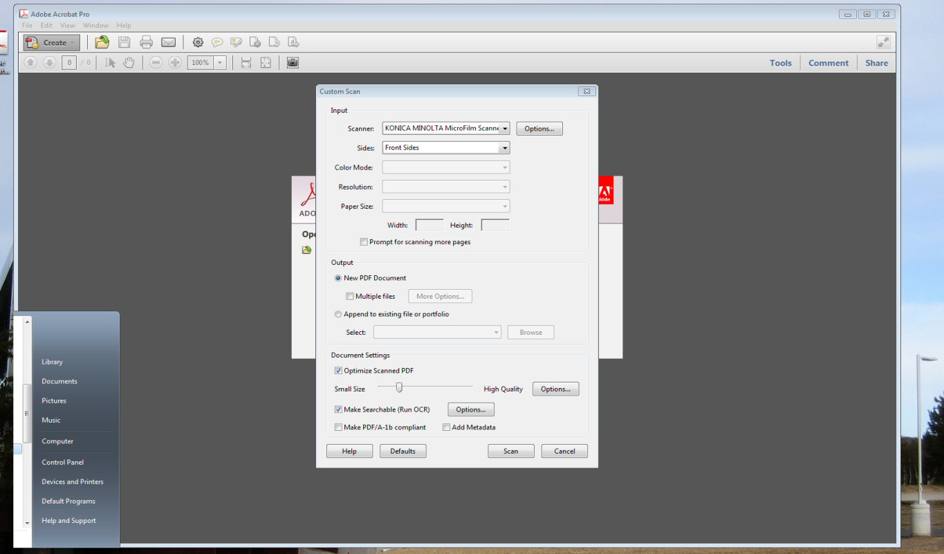

Step 9) A new window will appear. Set your resolution (DPI). Higher resolutions are not usually necessary for microfilm images. 300 DPI is recommended for printing. 200 DPI produces a coarser, fax-like quality, but will result in a smaller file size when saving the image. Click on “Preview”.

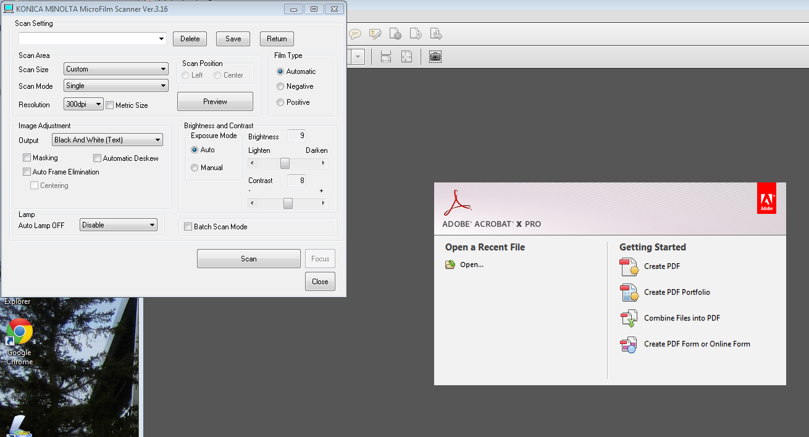

Step 10) The Preview Window will now appear. The dotted box may have to be expanded to cover the entire window area. Click on the Scan button again.

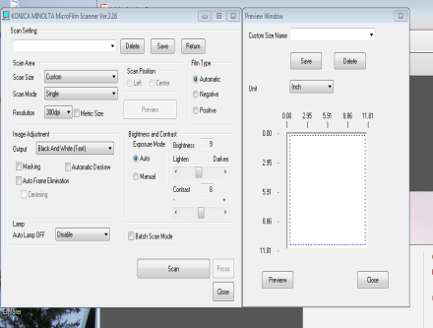

Step 11) The scanned image should now appear on the computer screen as a .pdf. At this point you can save or print the single .pdf page, or….

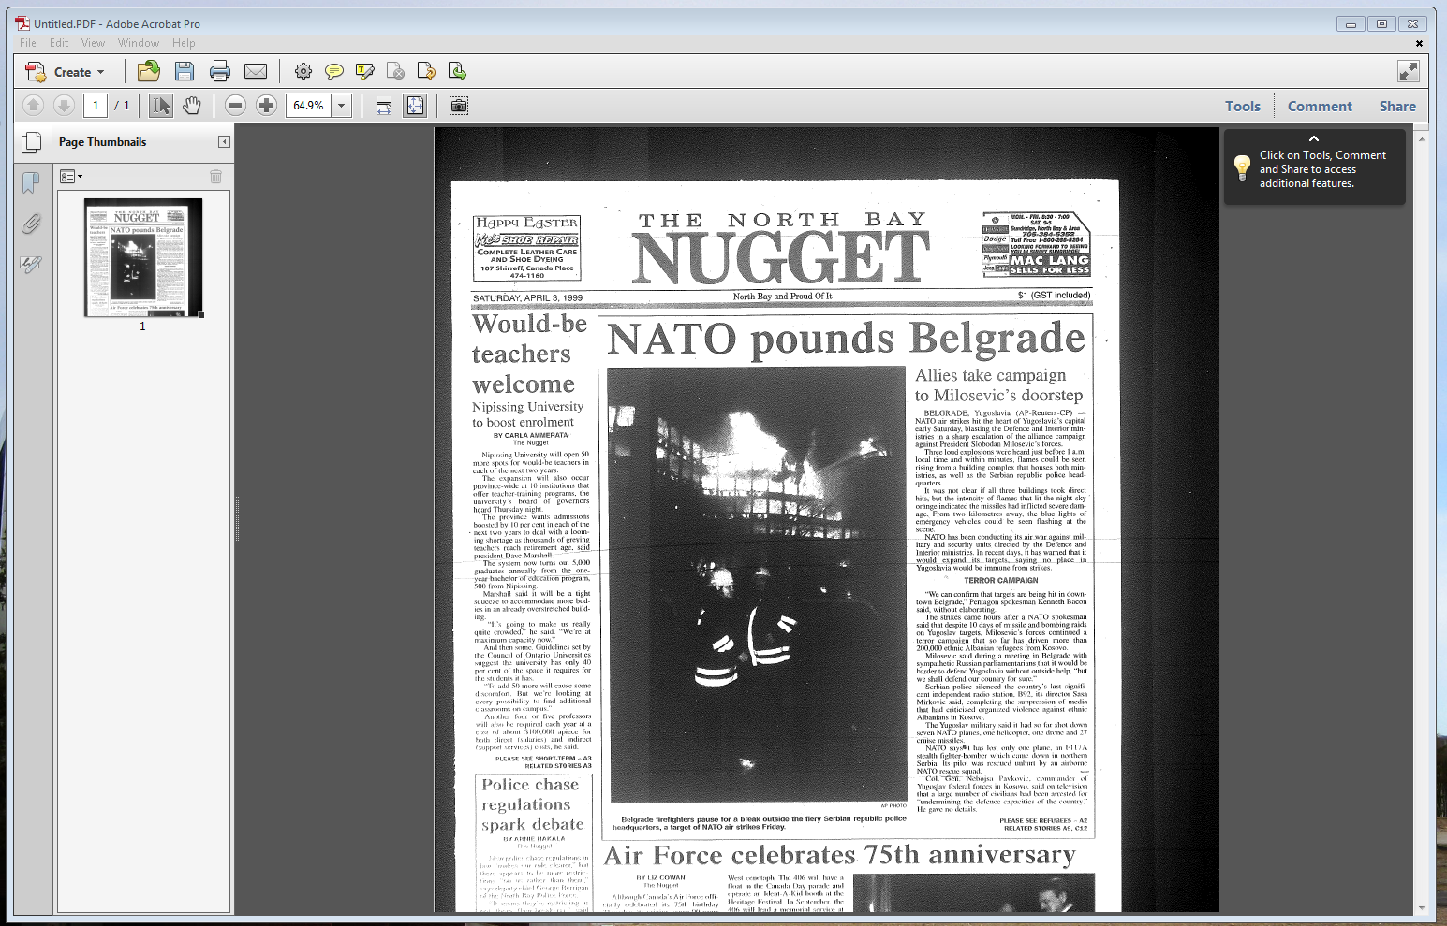

Step 12) … advance the microform to the next page and repeat the process from step 7. Subsequent scanned pages will be appended to the .pdf.

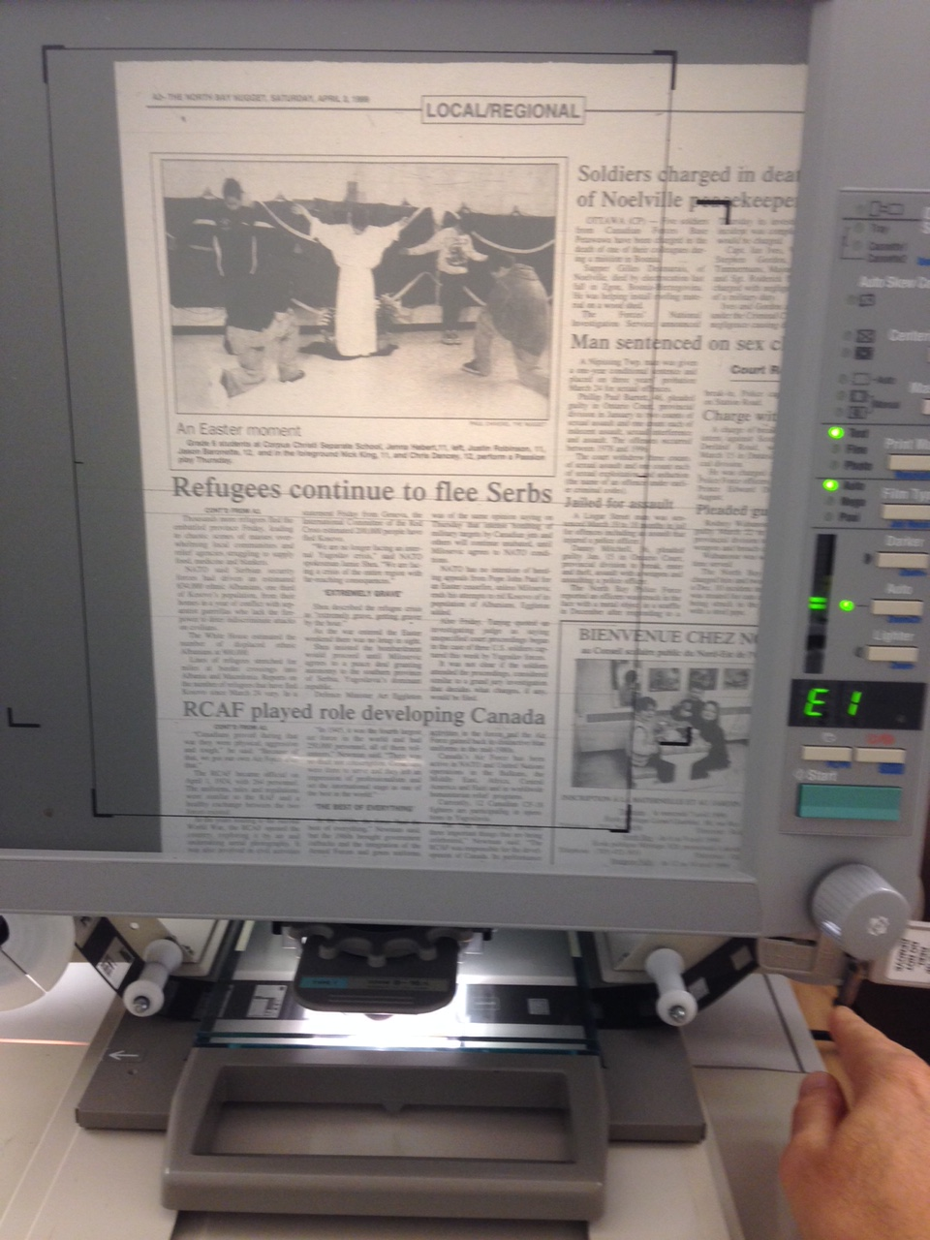

Step 13) When scanning is complete, the appended .pdf can be saved or printed. Printed pages will be sent to the print station in the Learning Commons.

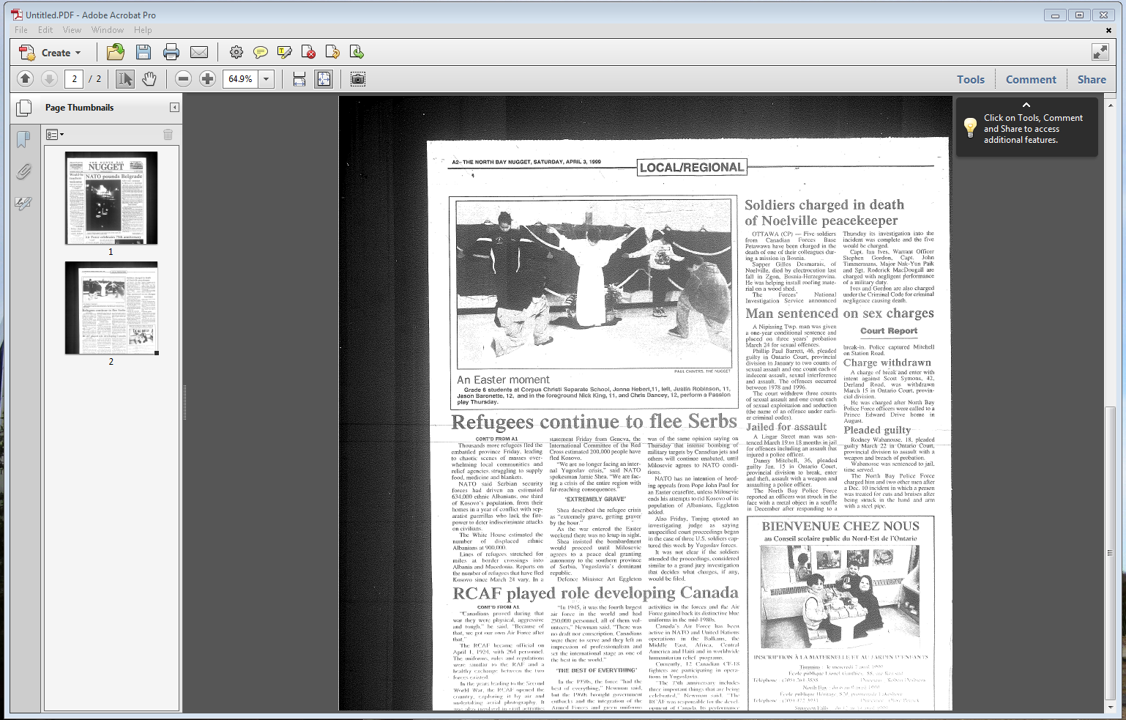

Step 14) Rewind the microfilm…

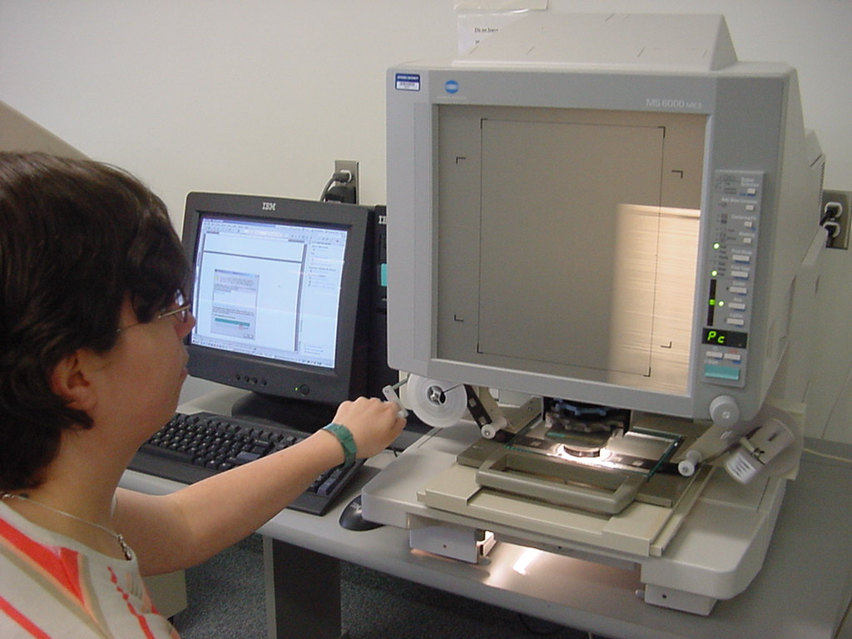

… and replace the microfilm in its box, and place it on top of the microfilm cabinets. Turn off the MS6000 Microfilm Reader/Scanner.

